GoodAct
Non Functional Requirements Document

By Raed Sherif, Anthony Edward, Ahmad Ehab,
Saif Abdelqader, Mohamed Kilani

ID | Non-Requirement Name | Implementation Description | Implementation Logic
NFR-01 | Password security. | User passwords are hashed. Plain text passwords are never stored or compared directly. | password_hash() on register, password_verify() on login. Real password never stored.  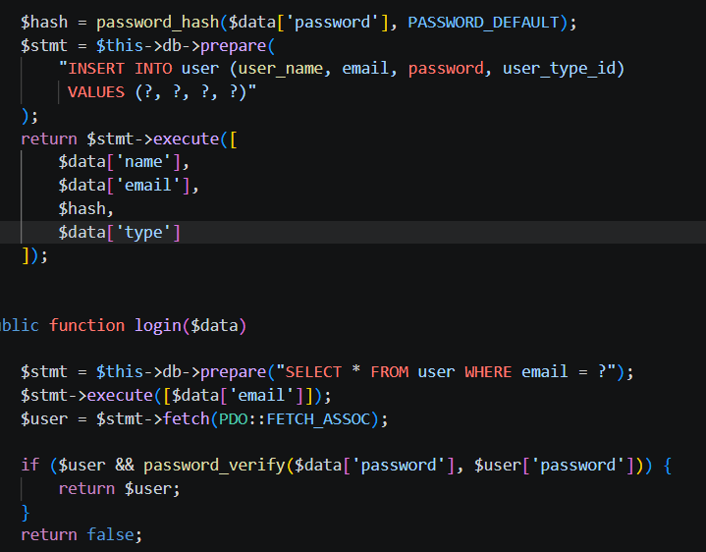
NFR-02 | Input validation and duplicate prevention. | Duplicate accounts are blocked by checking if an email already exists. HTML required fields and email type prevent blank or malformed submissions. | The system checks the form using the HTML “Required” to make sure no field is left empty. Also the system checks for duplicates, it checks whether the email is already registered.  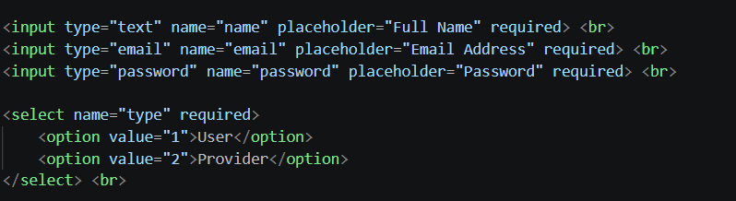  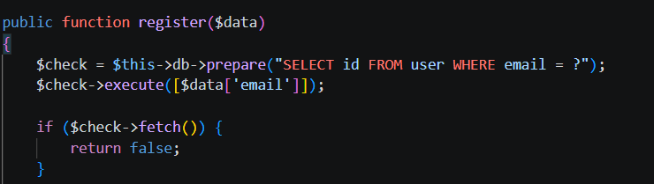
NFR-03 | Access Control | Every protected page verifies the session role before allowing any action. Users can only modify their own records. | Session role check at top of every controller and view. Also ownership is enforced to make the creator of the order or listing is the only one allowed to modify on it.  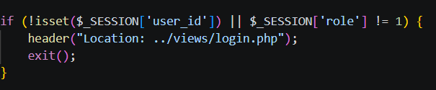  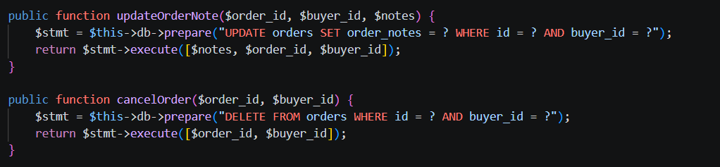
NFR-04 | SQL injection prevention | Every database query uses PDO prepared statements so user input is always treated as data, never as SQL. | prepare() + execute([$param]) used for every single database operation across all models.  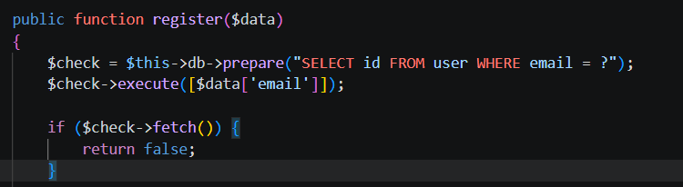
NFR-05 | Re-usability | The system demonstrates reusability. Navigation is implemented once and extended per user role using decorators, allowing the same structure to be reused across different roles without duplication. The database connection follows a singleton pattern, ensuring a single shared instance is reused throughout the application instead of creating multiple connections. Also sorting logic is implemented using interchangeable classes, allowing different algorithms to be reused. | 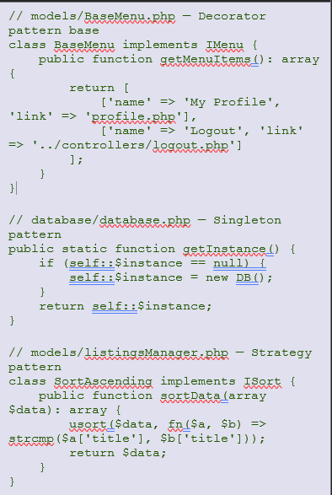
NFR-06 | Logger | Every login and registration attempt is automatically written to log file using the Observer pattern. | 